TITULO QUE TODAVIA NO SE
segundo titulo explicando algo mas sobre eso

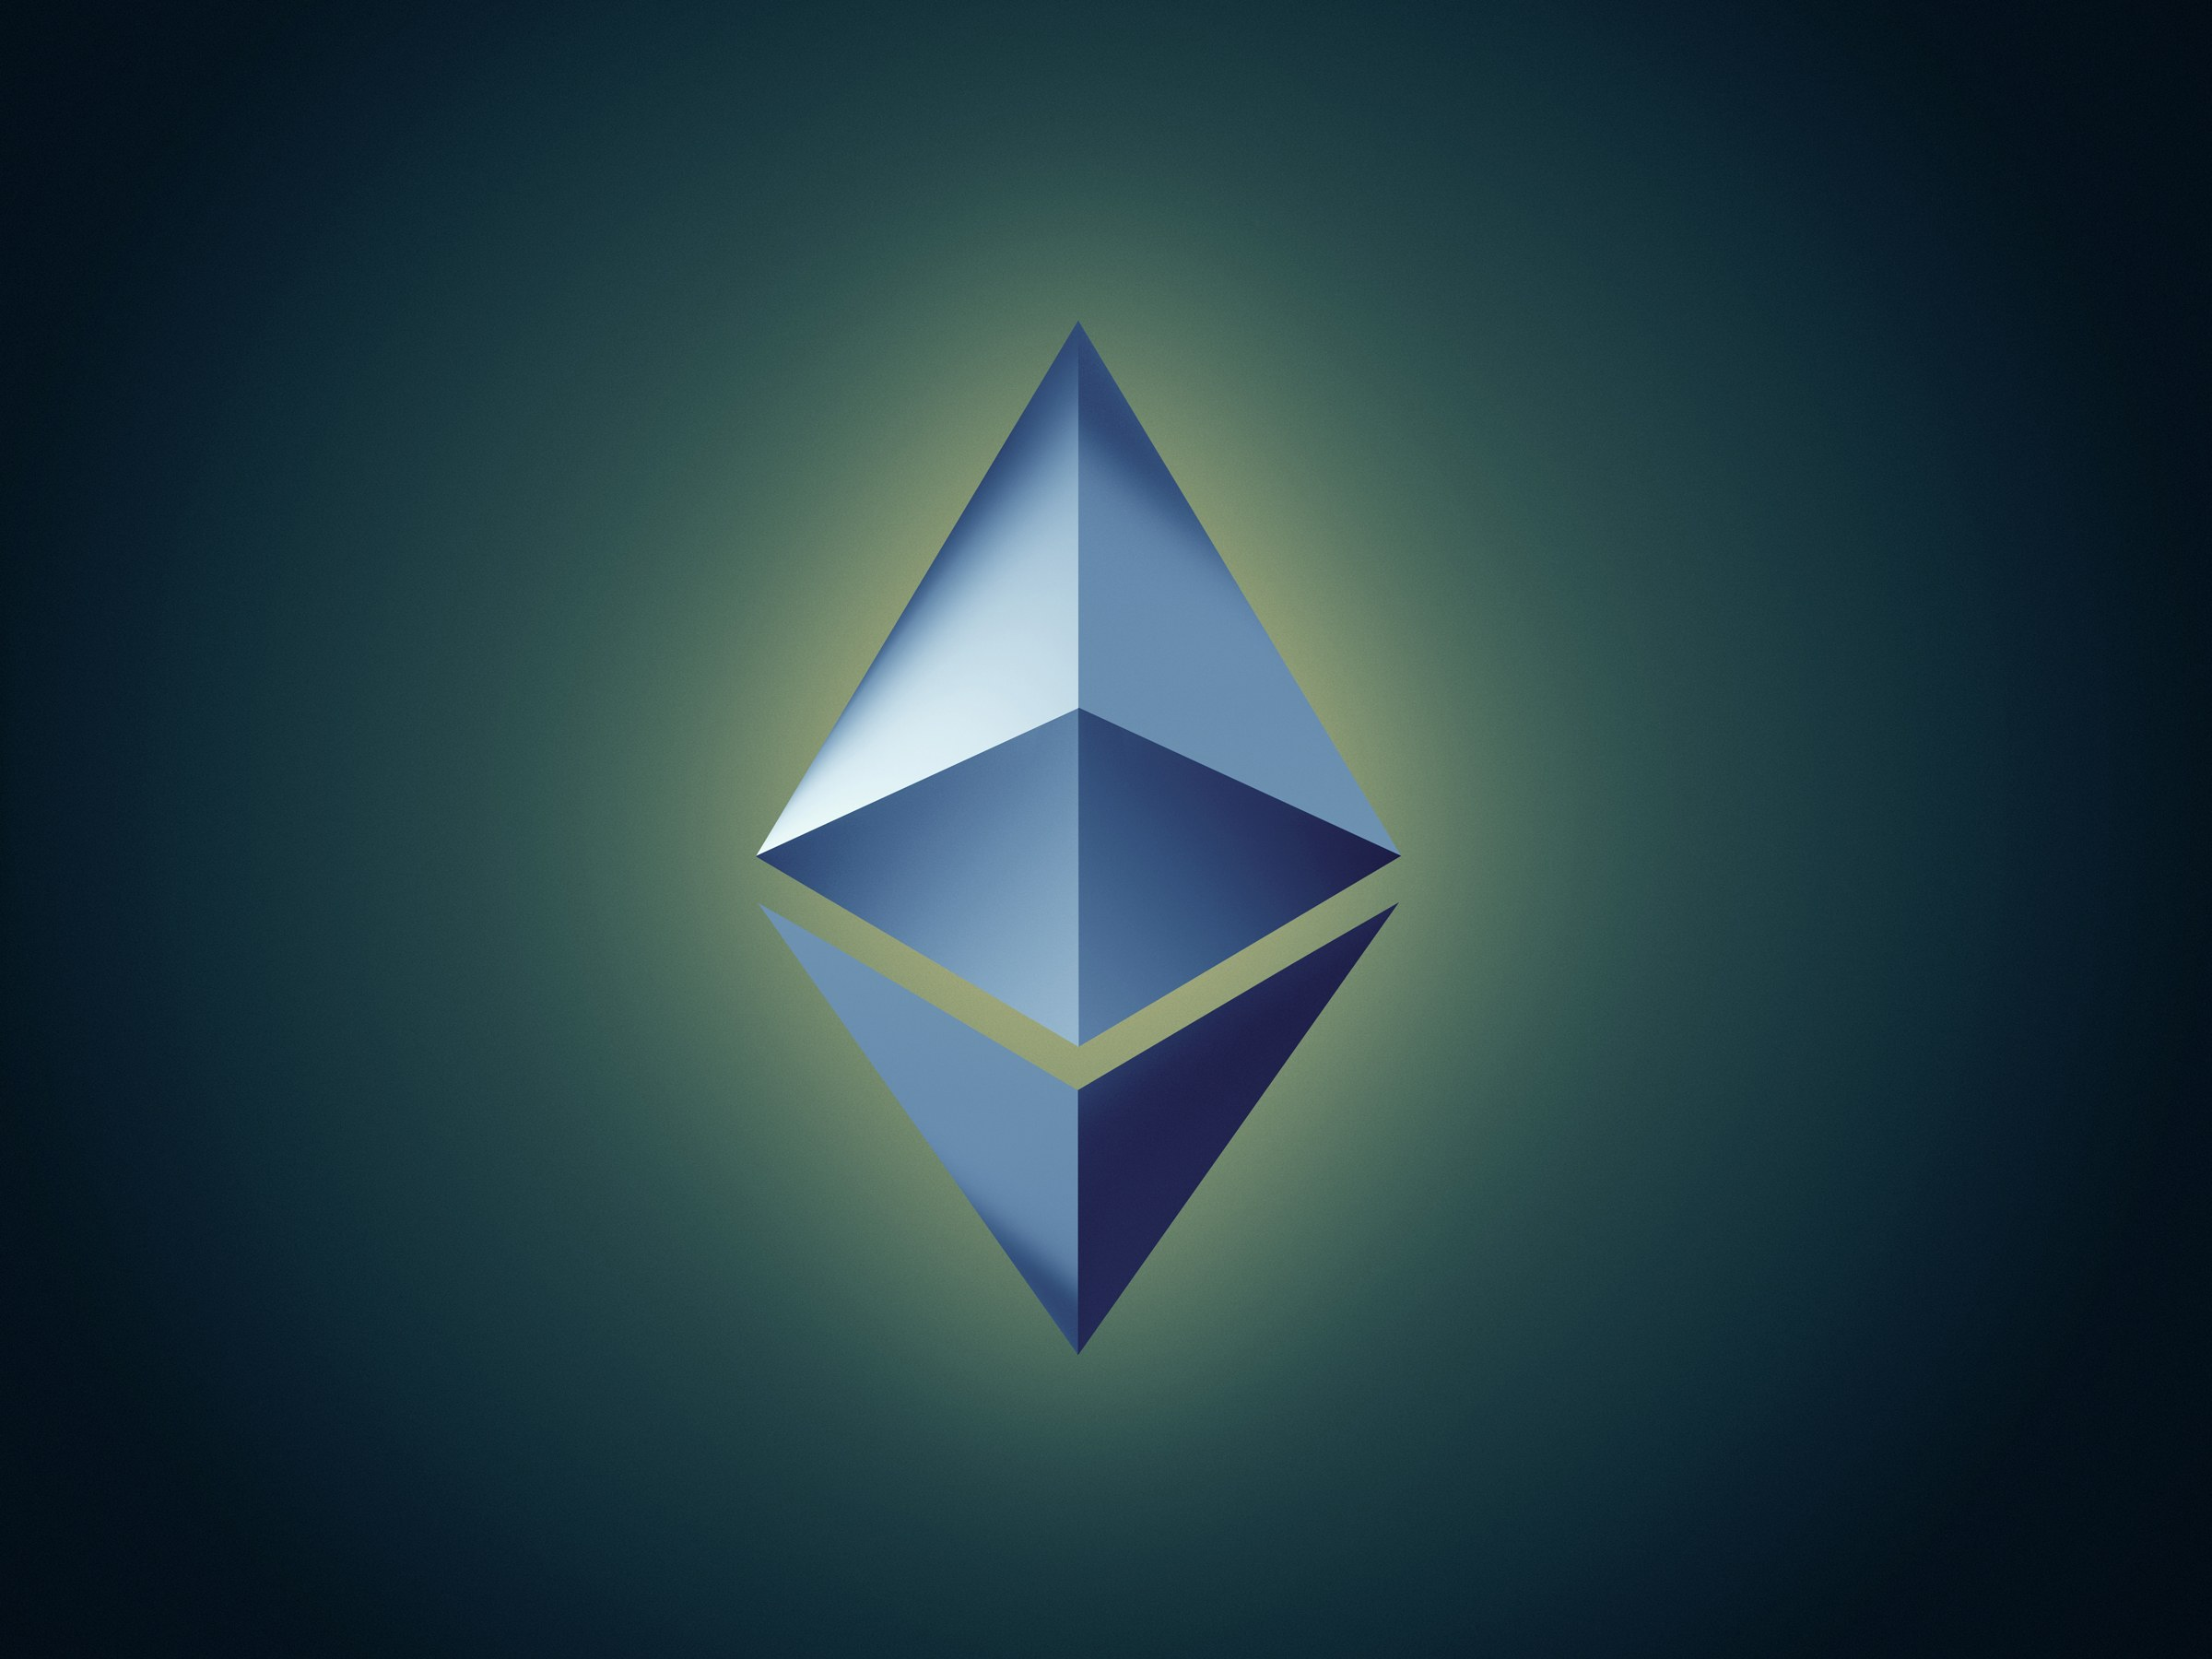

Jose Manuel Rodriguez Calvo

ABSTRACT
Este proyecto va a tratar sobre los protocolos de seguridad sobre una de las criptomonedas mas importantes hoy en dia, como es etherum. Explicare tanto sus inicios, lo que de verdad es etherum, que no es solo una criptomoneda y todas las cosas adyacentes a la seguridad sobre etherum. //el texto sera mas extenso pero por ahora no se me ocurre nada mas asi que escribo esto solo para maquetar el proyecto que tengo que entregar en 2 semanas y el que estoy empezando ahora.

INDEX
- Introduction
- Security of Etherum
- asdasd
- asdasd
- asdasddddddddasd
- asdeeafsfa
- safsfasfasf
- asdasd
- asdasda
- asdasdas
- References

Introduction
Etherum is a digital platform which main mission is the implementation of descentralized applications (dapps) and smart contracts. Dapps are softwares that remove intermediaries in any existing centralized service, by allowing that anyone trust in an unknown counterpart to carry out sundry types of agreements in a totally digital way.
Originally the concept “smart contract” was used to describe the using of information systems (or other automated media) which purpose was the realization of some agreements.
Dapps and smart contracts work in the blockchain Etherum, which had its initial architecture conceived by a young genius russian at the age of 19 yeas, called Vitalik Buterin.
Anyone can load applications or smart contracts to the Etherum network. The development team of the platform searched to do all in the simplest form for extend the access to this tecnology. This allow to the developers the possibility of write in differents programming languages: C, C++, Go, JavaScript, python or java among others .
The developers of application doesn’t need infraestructure to deploy and implement their applications. Anything that is able to be represented mathematically can be modeled, guaranteed and commercialized through Etherum, after of be writted in some of the accepted languages by the platform. After of that, the turn is of the platform which will be to execute it in few of seconds.
Once loaded, the agreement will be store in th blockchains and other users will be able to log on directly. Like the result of the agreement, based on the identification of the conditions established, it will automatically comply the stipulated conditions on itself and will be able, for example, to send or receive amongs of differents persons.
The Etherum has its own coin called ether (ETH), in a similar way of the bitcoin, it doesn’t depends of a bank or a central authority. The ether has basically two purposes:
To execute a dapp or a smart contract in the network of the platform, the user must pay by the usage of the power of processing of the network and the second purpose is just like happens with bitcoin, those who participate in the process of mining of Etherum, namely, check the blocks of transaction, will be rewarded with a among of ETH . The ether is extracted through an algorithm called Etash, which was built to balk its prosecutions by means of specific hardware, like the ASIC chips, used for extracting bitcoin. Therefore, the mining is done through of GPU, simpler hardware, what increases the decentralization of the process, unlike what happens in the btcoin industry, very concentrated in investors capables of hold an operation on a large scale and an intensive use of stock.
All this characteristics do that the security topic on Etherum is been considered very important, to allow the correctness and attack-proof of its funcionality.

Security of Etherum
Para que una criptomoneda funcione los nodos de la red están continuamente comprobando las transacciones, es lo que se denomina Proof of Work (PoW). La seguridad de este sistema depende de la cantidad de nodos (potencia de cálculo total de lo mismos) y de que no haya un único usuario con mucha capacidad dentro de la red (pues podría intentar un ataque malicioso).
Ademas para mantener el funcionamiento correcto y seguro de la aplicación Etherum usa un algoritmo de seguridad denominado etash, que es una mezcla de protocoles SHA3.

REFERENCES
[1] https://www.xataka.com/seguridad/como-ethereum-esta-disputando-el-papel-de-criptomoneda-mas-segura-sobre-blockchain-a-bitcoin
[2] https://www.tuexperto.com/2018/03/05/resuelven-importante-fallo-seguridad-ethereum/
[3] https://en.wikipedia.org/wiki/Ethash
[4] https://en.wikipedia.org/wiki/SHA-3
[5] https://miethereum.com/ether/bitcoin-vs-ethereum/
[6] https://bravenewcoin.com/assets/Whitepapers/Ethereum-A-Secure-Decentralised-Generalised-Transaction-Ledger-Yellow-Paper.pdf
[7] https://coss.io/documents/white-papers/ethereum.pdf
[8]https://www.ethnews.com/ether

